**ECE 2029 INTRODUCTION TO DIGITAL CIRCUIT DESIGN**

**Lab 2: Introduction to Xilinx Vivado Design Environment**

**Sign-Off Sheet**

**Date:**

**Student 1:** Ciara Murphy

**Student 2:** Brandon Simpson

**YOU ARE RESPONSIBLE TO COMPLETE ALL THE ASSIGNMENTS IN THE CHECK LIST BELOW IN ORDER TO GET FULL CREDIT**

|  |  |
| --- | --- |
| **Check List** | |
| **Assignments** | **TA Sign-off** |
| **Pre-Lab** (**MUST** be completed before the start of the lab)  Download Vivado on your machine  Watch the tutorial: <https://youtu.be/tOwMmBI_XNo>  Create a project  Design Entry & Synthesis |  |
| **Lab part**  Create and add a constraint file |  |
| Synthesis & Simulation for Timing Verification |  |
| Implementation and Downloading |  |
| Programming the serial flash. |  |
| **Submission Details: (Each student should submit files individually on Canvas)**  **Project File(s) Upload on CANVAS**   * 1. Upload Sign-off Sheet   2. Upload your project files (zip the folder)   Name your file as: lastname_labn_D’20   * 1. Present your work   Record a 2-3 minute video showing that all parts of your lab functioned properly.  **OR**  Show your work to TAs for the sign-off.   * 1. Upload the Writing Assignment (Debugging and Troubleshooting errors FAQ’s) – OPTIONAL | |

**Due Date: 04/22/2020**

**Pre-Lab**

**IMPORTANT:** Watch the tutorial before you begin…

<https://youtu.be/tOwMmBI_XNo> 25:12 min

Usually, laboratory exercises will have pre-lab assignments which are to be completed before your lab session and must be signed-off by the TA during your lab session.

Pre-labs help you to become oriented to the problem before you enter lab, help complete your design in advance and prevent wasting time in lab. This second lab is a straightforward tutorial and does not have a pre-lab.

**To complete this pre-lab, you will need to install the Vivado on your machine**, the link to download the software is: https://www.xilinx.com/support/download.html

**Assignment**

In this second lab you will start by implementing the basic logic gates AND, OR, NOT and the compound exclusive OR gate (XOR) and verify their truth tables. Then you will implement a multi-gate circuit. You will do this using the Verilog hardware description language.

1. 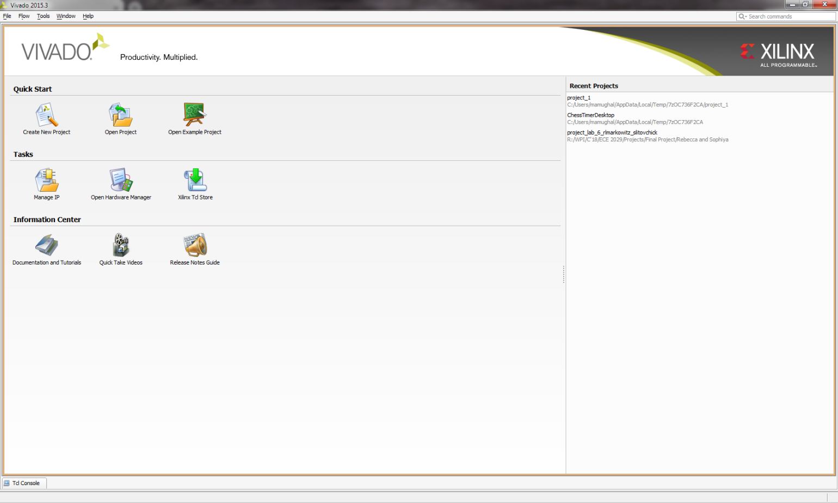Start Vivado Design Suite by clicking on Vivado icon and then selecting Create New Project from the menu. And click next to move to next step.
2. Enter a project name. You should use **your network drive** as the project location for your files. Make sure there are ***no spaces or special characters (- and _ are allowed)*** in the folder name that you create for your work. If you must create you project on the local disk be sure to back it up to your network drive when you’re done at the end of lab. Lab machines can be re-imaged at any time and you could lose your work if it is not on your network drive! Each partner should have a copy of all the work!

Click *Next* and then select the RTL project type. Be sure to check the “Do not specify sources at this time” box and click Next:

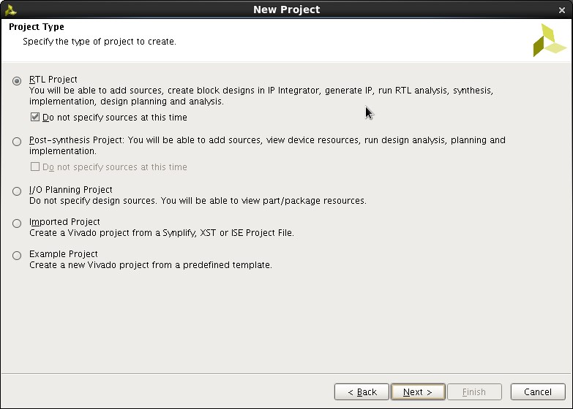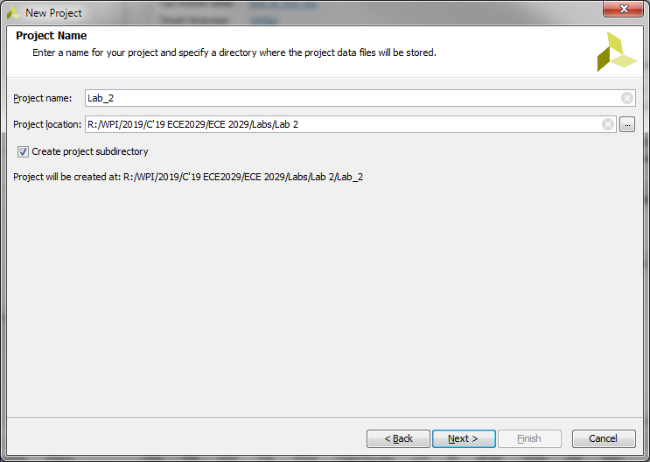

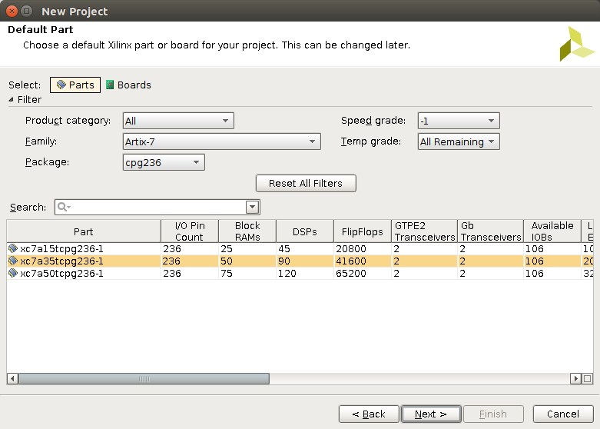Click next and select the correct Xilinx Artix 7 FPGA that is on the Basys3 board (XC7A35T-1CPG236C)

Click Next, and then Finish on the New Project Summary Page. The Project Window opens:

**Design Entry**

1. Under the Project Manager, select Add Sources to begin designing your new project.

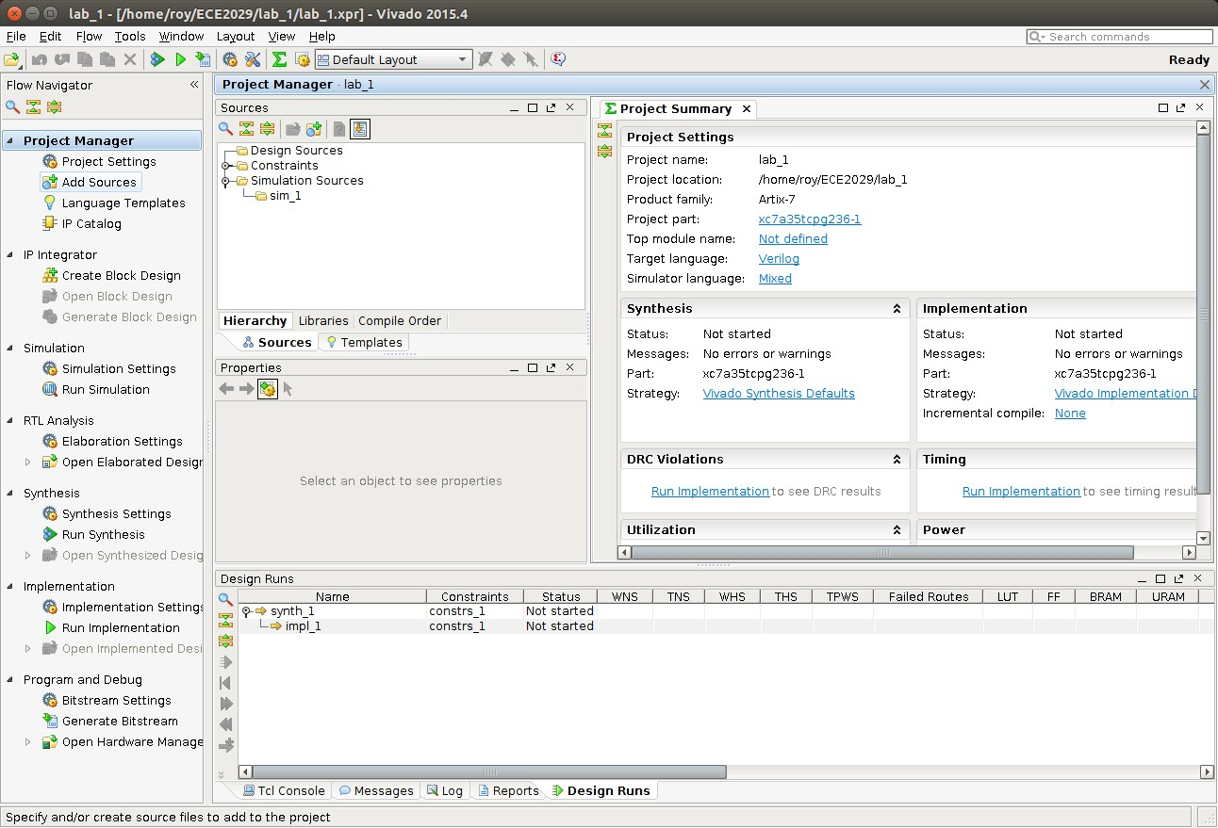

1. Select Next and then select Create File (click on the + symbol) and enter the file name for the circuit.

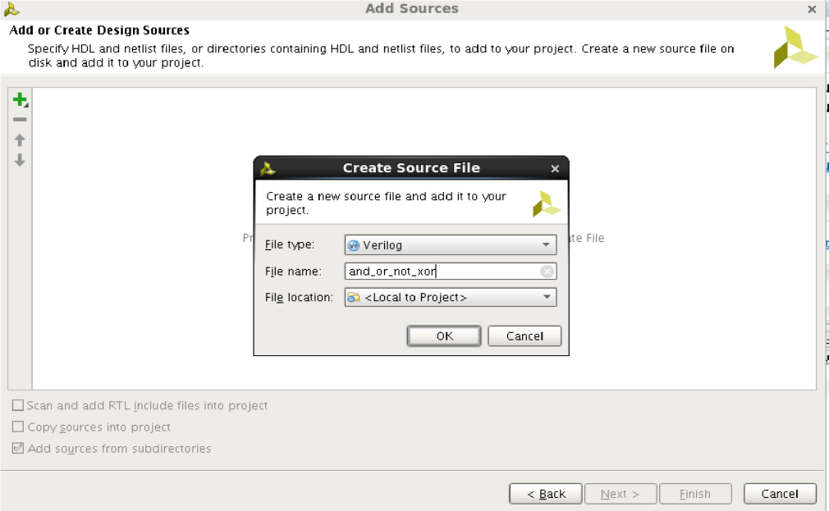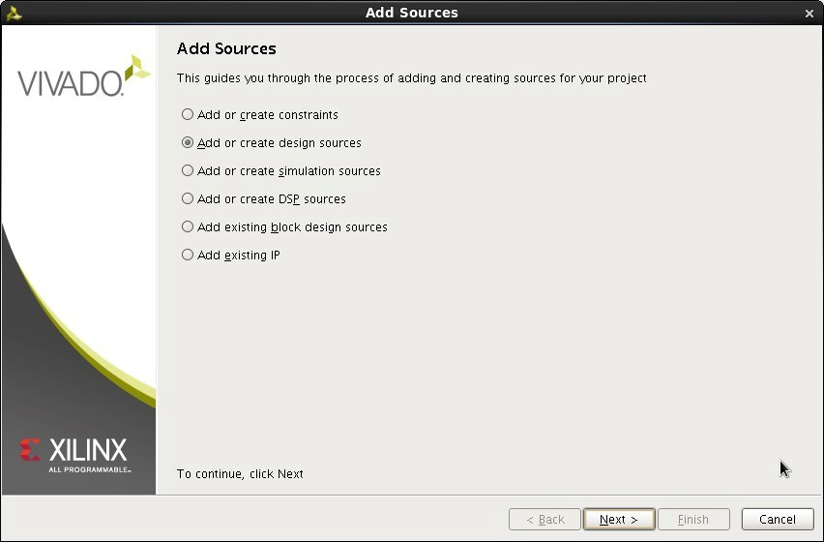

1. Then click OK and Finish. We can now specify the inputs and outputs to create our AND, OR, NOT and XOR gates. We will use three slide switches as inputs and 4 LEDs on the Basys3 board to display the outputs of each gate. Inputs A and B will be the inputs to the AND, OR and XOR gates, and C will be the input to the NOT gate.

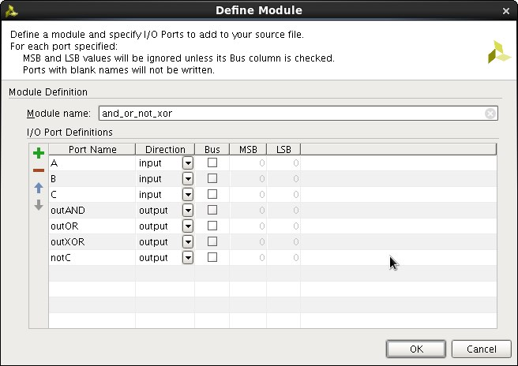

1. Click OK. Back in the Project Manager Sources window double-click the new and_or_not_xor.v file and you will then see the Verilog file appear in the window on the right. Add your name and a description of this file to the header description. You should ALWAYS complete the comment block at the top of each Verilog module that you write. This is basic professionalism.

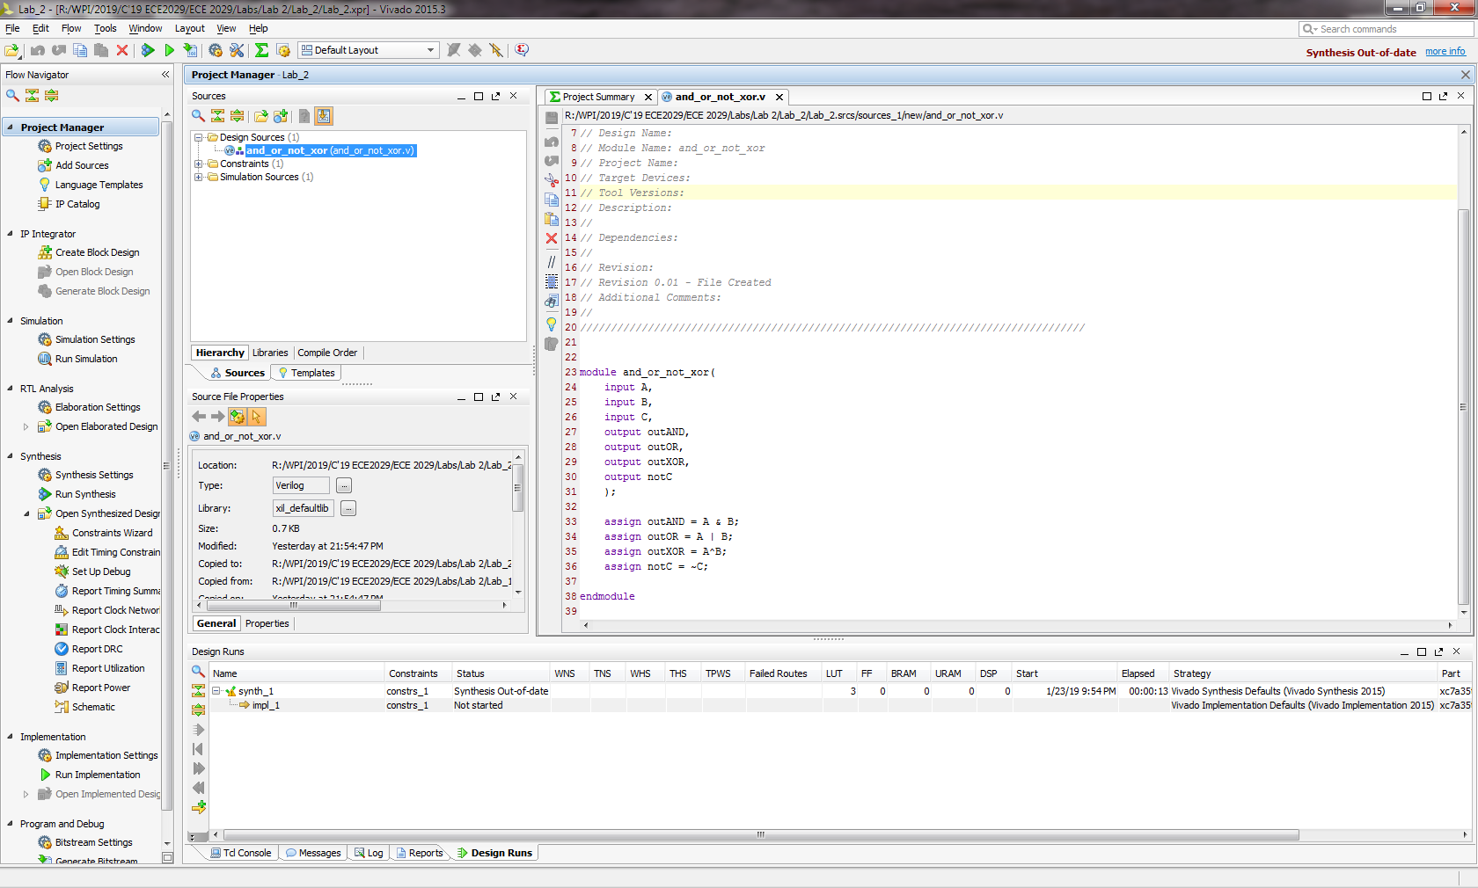

**🡪** Complete rest of the code for OR, XOR, & NOT Gates.

1. We can now add the Verilog statements to design our gates. Enter the code to your and_or_not_xor.v file as shown in the figure on the right.
2. Now we can synthesize the design. Click Run Synthesis in the Project Manager window. After synthesis is complete there should be no errors or warnings reported. If you open the synthesized design you can see a device level representation (this is mostly empty since we just have a very simple design that only uses a tiny, tiny fraction of the available FPGA resources).



1. Now we can synthesize the design. Click Run Synthesis in the Project Manager window. After synthesis is complete there should be no errors or warnings reported. If you open the synthesized design you can see a device level representation (this is mostly empty since we just have a very simple design that only uses a tiny, tiny fraction of the available FPGA resources).
2. You can also look at a schematic representation to see the input and output buffers and the Look Up Tables (LUT) used. LUTs can be used to implement any truth table with a certain number of inputs. Notice that since AND, OR and XOR all have A and B as inputs they are implemented in the same LUT.

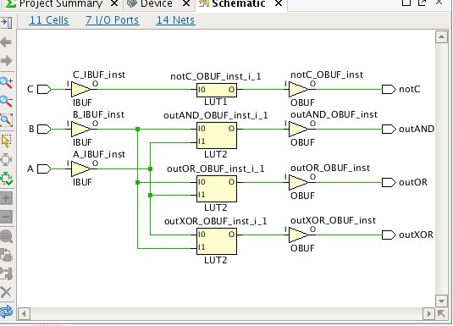

1. Save your file, you will continue working from here in the lab.

See you in the Lab…☺

